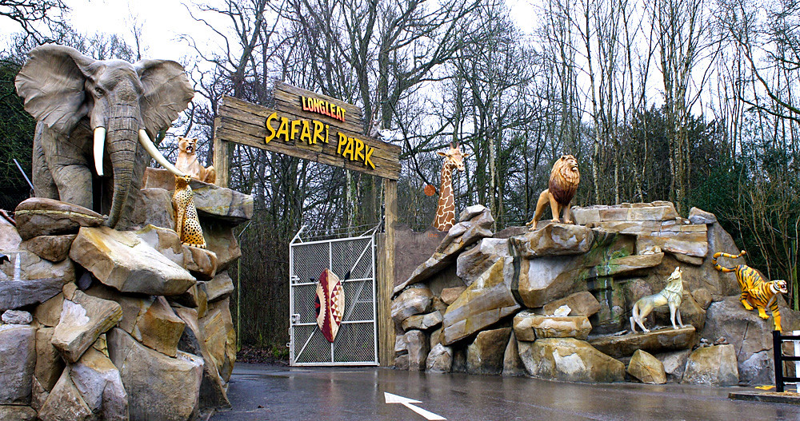

About Longleat Safari Zoo Park

What is Longleat safari Park Zoo? and where is located established?Longleat Safari Park, located in Wiltshire, England, is renowned as the world's first drive-through safari park outside Africa, established in 1966. It is situated within the grounds of Longleat House, a historic Elizabethan mansion built in the 16th century. The estate is owned by the Thynn family,with the current proprietor being the 8th Marquess of Bath.

Opening & Closed Timings

Open daily from 10:00 AM to 5:00 PM (off-peak) and until 6:00 PM (peak times).

lease note that these times can vary,and it's advisable to check the official website for the most up-to-date information.

Longleat hosts various family-friendly events throughout the year, including the renowned Festival of Light during the winter season.

While there are no specific "Ladies' Days," the park offers a range of activities suitable for all visitors. For detailed information on upcoming events,it's best to consult the official website or contact the park directly.

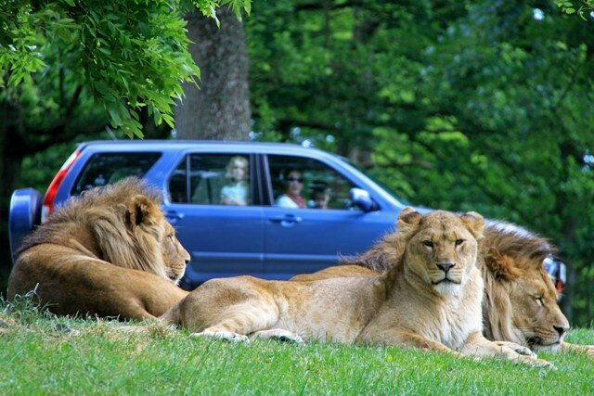

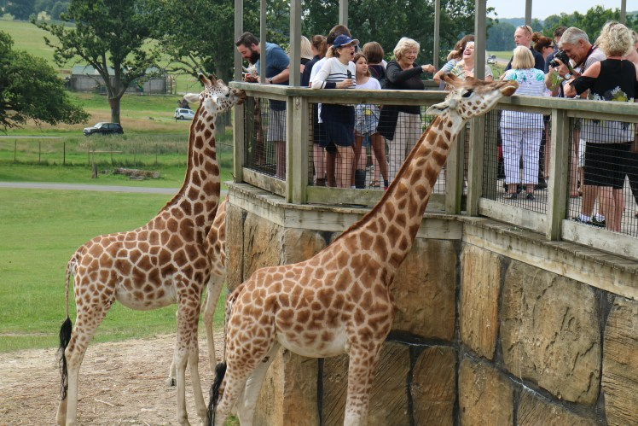

Animals List

Safari Drive-through: Home to over 500 animals, including lions, tigers, rhinos, and giraffes:

Gorillas

Sea lions

Koala

Hippos

Tigers

Rhinos

Giraffes

Lions

Monkeys

Address & Contact

Address:Longleat Safari Park, Warminster, Wiltshire, BA12 7NW, United Kingdom.

Email: For specific enquiries, you can fill out the contact form available on their enquiries@longleat.co.uk.

Phone: For urgent enquiries, you can call their Supporter Contact team at +44 1985 844400.

For the most accurate and up-to-date information, including ticket prices and event schedules, please visit the [official Longleat website](https://www.longleat.co.uk/).